Before starting up the API in Visual Studio, the State Database needs to be updated.

At the top Search Bar, select: Package Manager Console:

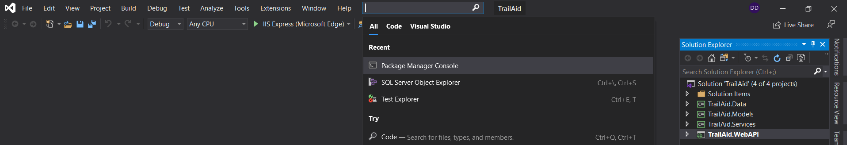

This creates a Package Manager Console window (usually at the bottom of the program window).

In the Package Manager Console window, under Default Project, select TrailAid.Data.

Next to PM>, type: update-database

Hit: Enter & the States will be Updated to the Database.

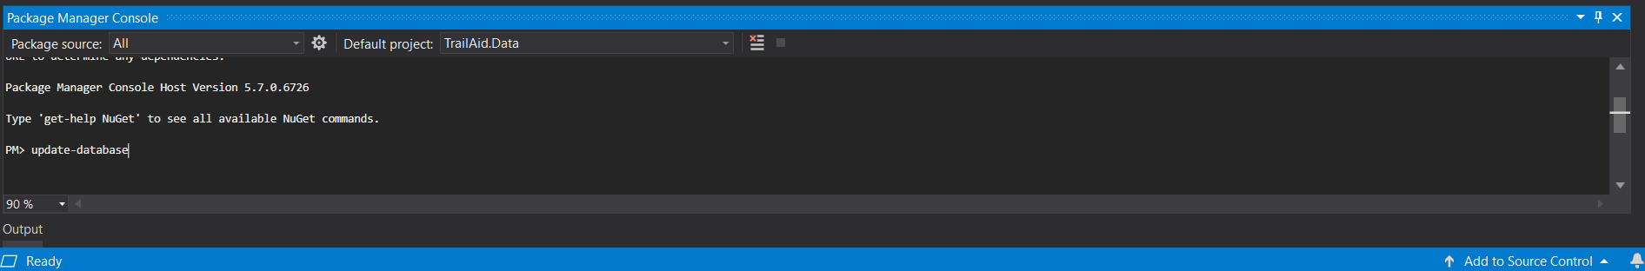

You can now run the API & begin accessing it with Postman.

Using Postman, Register an account (https:// … /api/Account/Register):

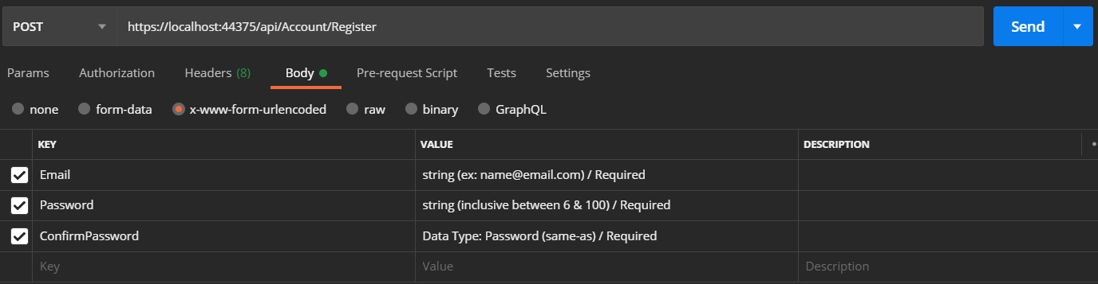

Generate a token (https:// … /token):

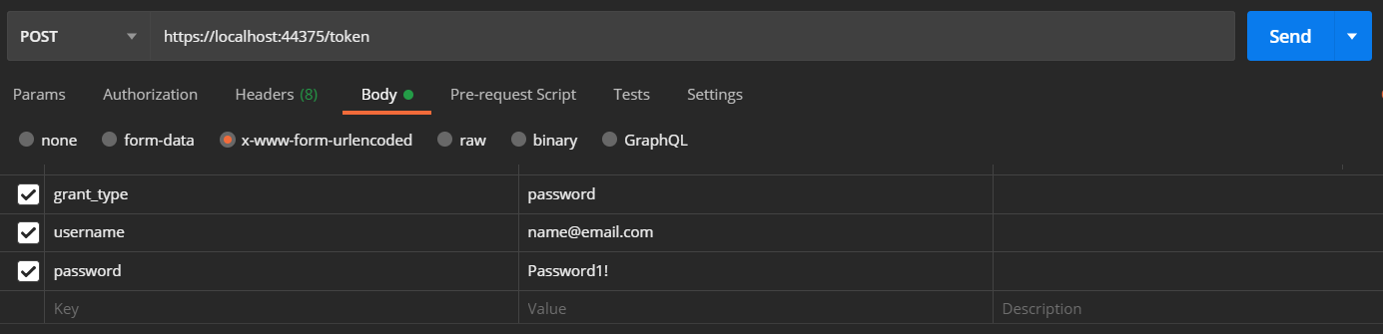

The grant_type is password. The username is the Email entered in the Account Register.

The password is the Password entered in the Account Register.

This will create a token:

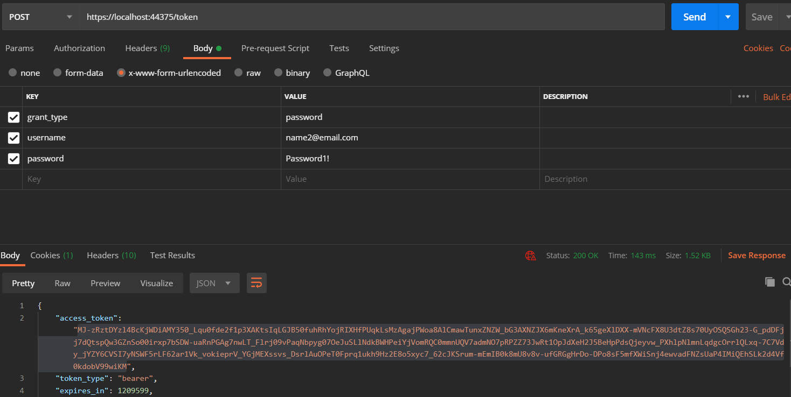

Any tabs from here on will need to have this token placed in the Authorization.

Copy the token (between the quotations). In the Authorization tab, select Bearer Token, & paste the information into the space for Token:

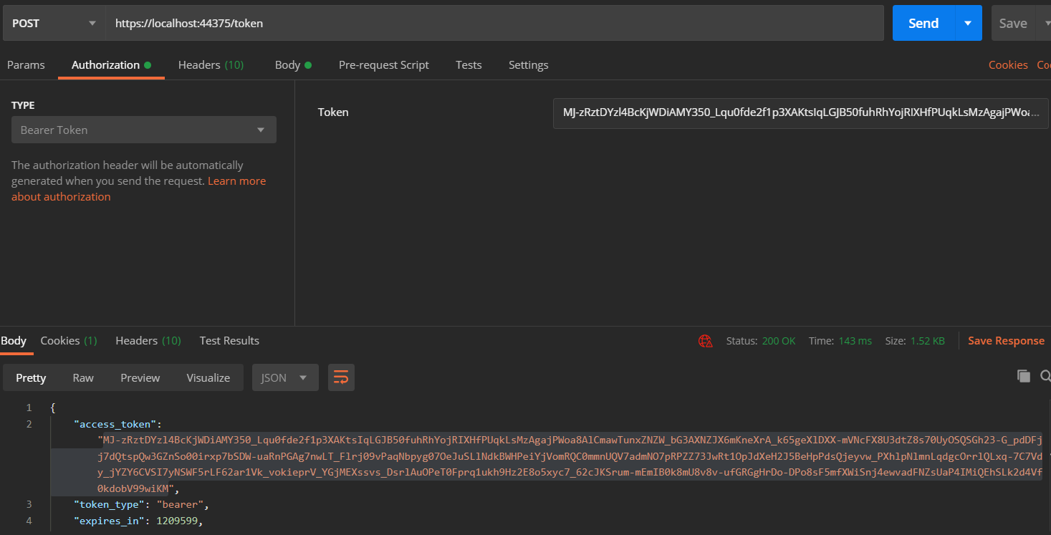

Create a User (https:// … /api/User):

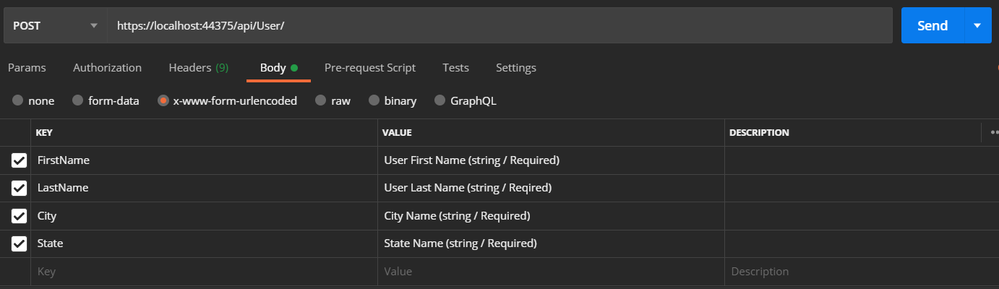

Create a List of All Tags (https:// … /api/AllTags):

This will initially be an empty list, but is important to be created.

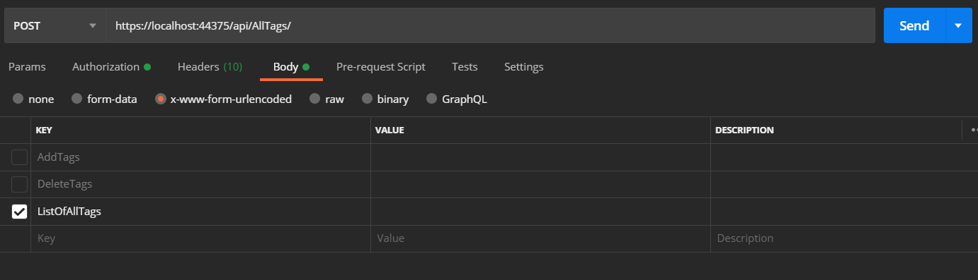

How to add Tags to the All Tags (https:// … /api/AllTags):

Notice this is a Put (not a Post). These are optional tags. When creating Trails, if tags are used, they need to have been entered to the AllTags in this way.

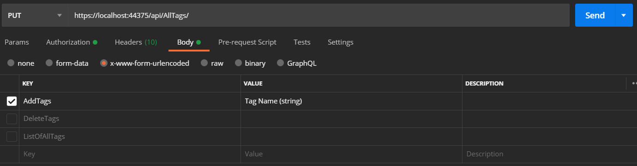

Setup / Get the States ((https:// … /api/State):

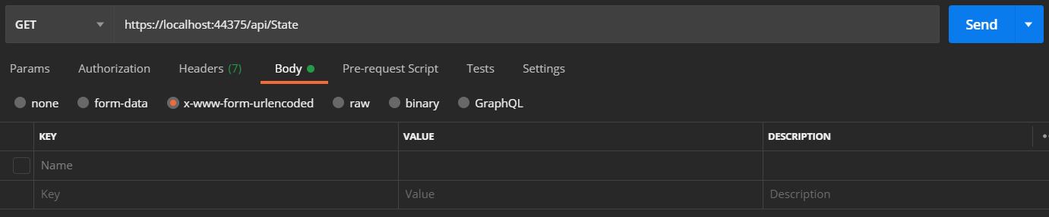This will show the list of States from the Updated Database (performed earlier). The State ID will be used when setting up the City in the next step.

Create a City (https:// … /api/City):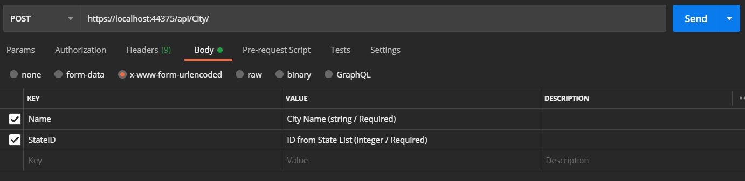

Create a Park (https:// … /api/Park):

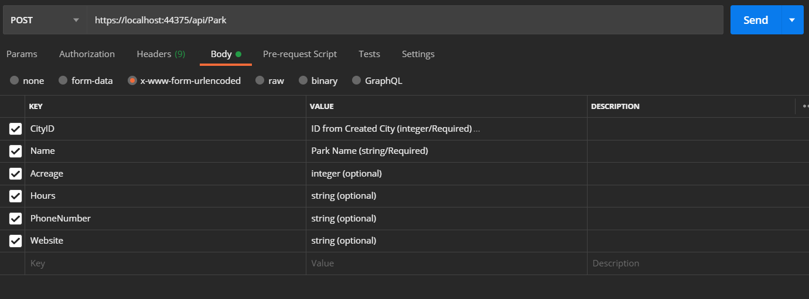

Create a Trail (https:// … /api/Trail):

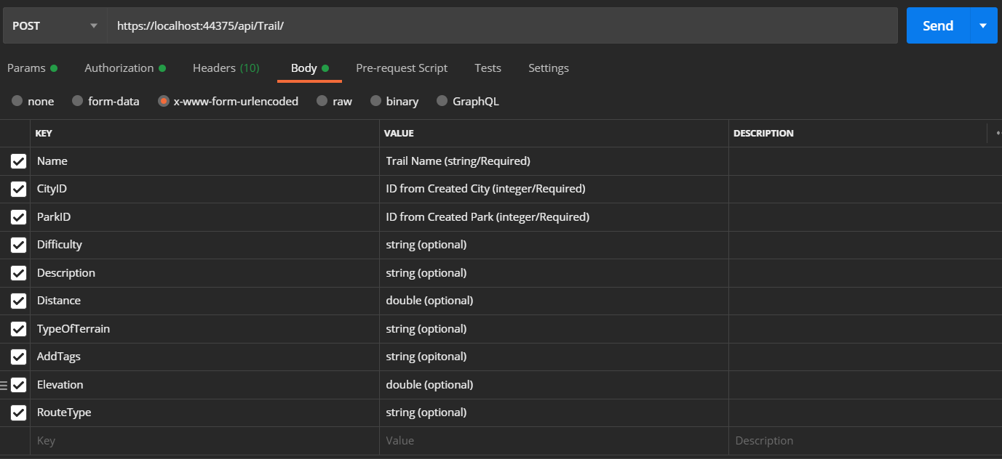

Create a Visited (https:// … /api/Visited):

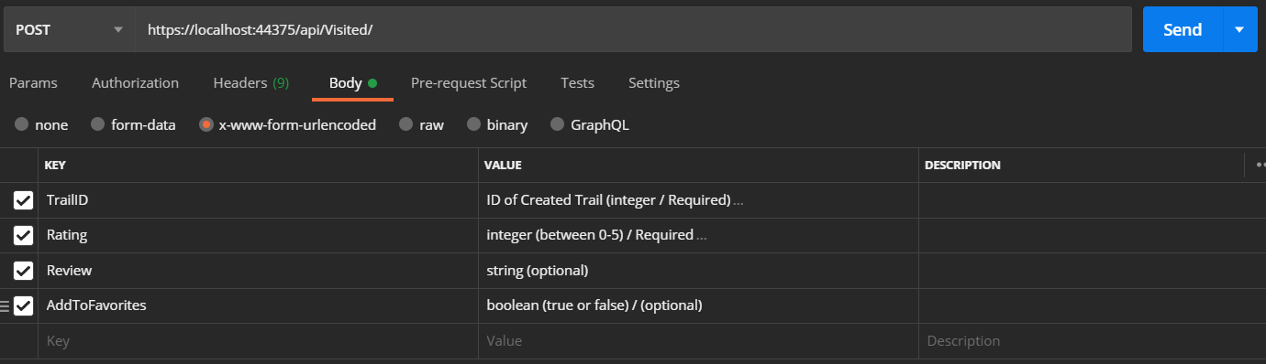

After all these are created, all of the features of the API will be available.